STA141 Homework3 Haozhe Gu 999200555

**The codes and results derived by using these codes constitute my own work. I have consulted the following resources regarding this assignment: NONE**

**Question 1**



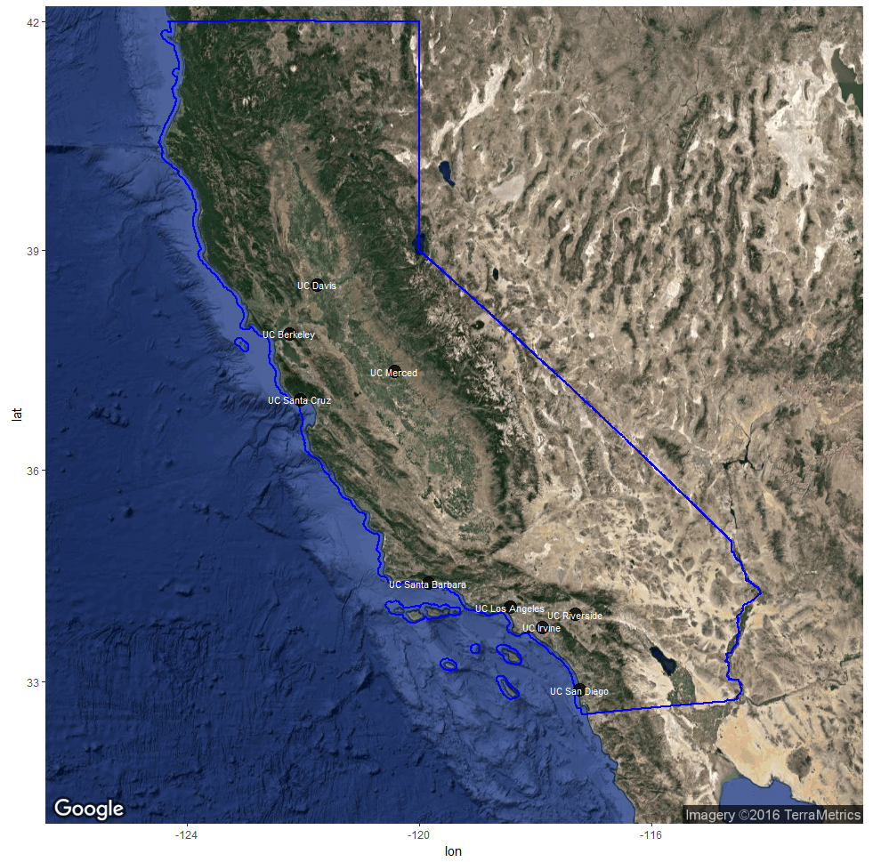

The graph above shows satellite map of California with state boundary. It also indicates the location of the university on the map.

1. The following graph displays information on relative rank (Larger fonts means better rank), Student population (darker blues means less enrollment) and percentage acceptance rate (more transparent point means less percent of acceptance). From the graph, UC Merced and UC Riverside seem to have worse relative rank. UC Berkeley seems to have low percentage acceptance rate and UC Los Angeles seems to have a large student population.

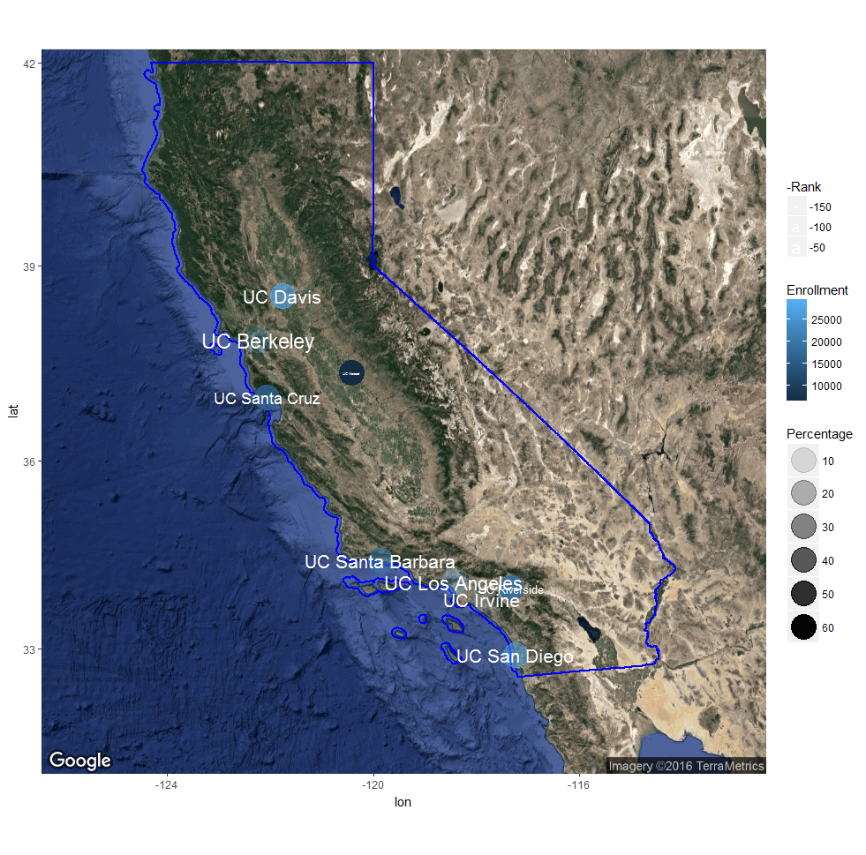



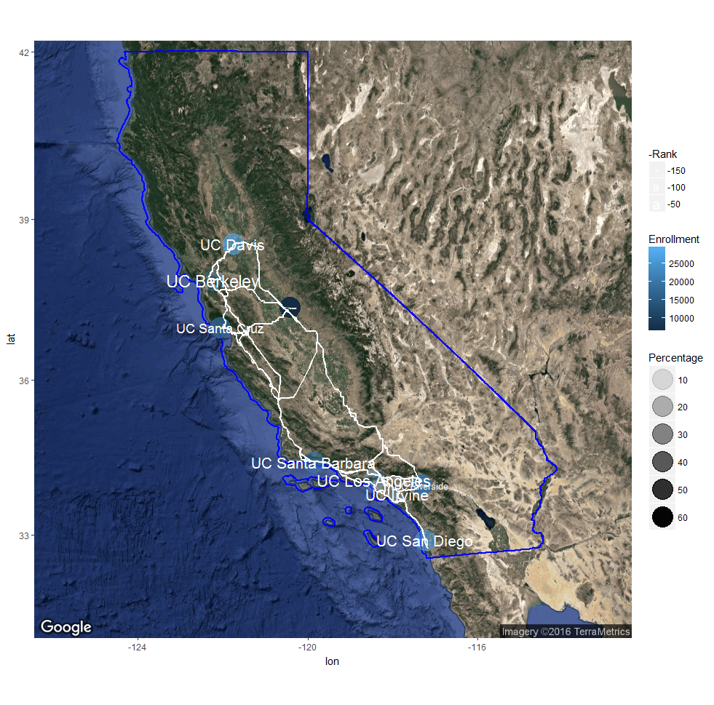

The graph above adds bicycling routes for each pair of universities with white lines.

Question 2

1. The 36 pairs of possible distance are shown by the following table

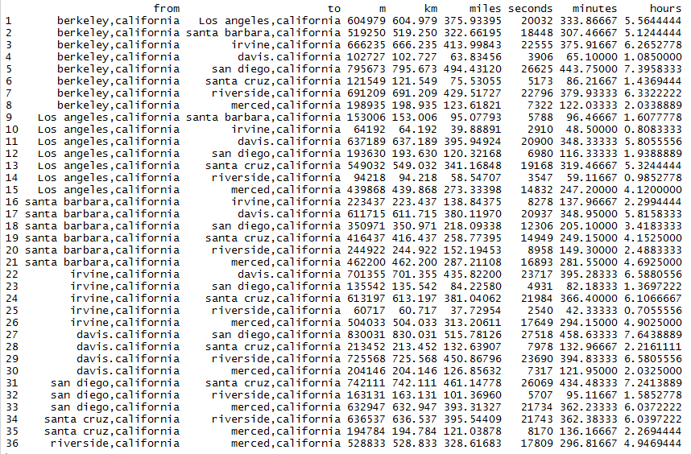

1. The following graph connect nodes that have distance within 100miles.

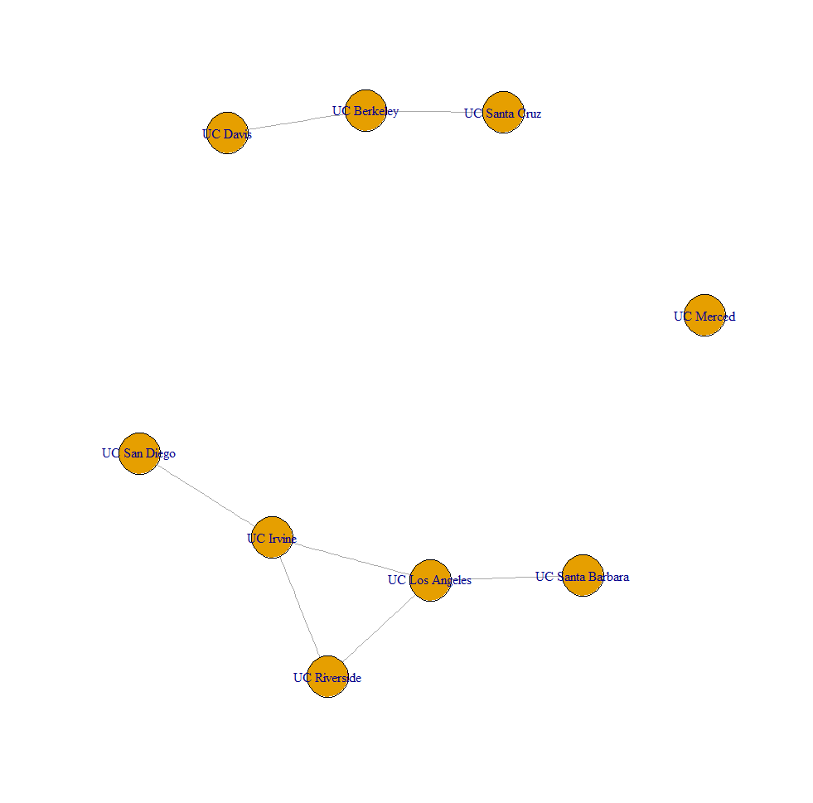

1. From the graph above, UC Merced has distance more than 100 miles to any other universities. The distance between UC Davis to UC Berkeley and UC Berkeley to UC Santa Cruz are within 100 miles. The UC Riverside has less than 100 miles distance to both UC Irvine and UC Los Angeles.
2. The plot below adds red color for university with more than 20000 student population and blue for those with less than 20000 students. From the plot, UC Merced, UC Riverside and UC Santa Cruz are the only three university with small student population.

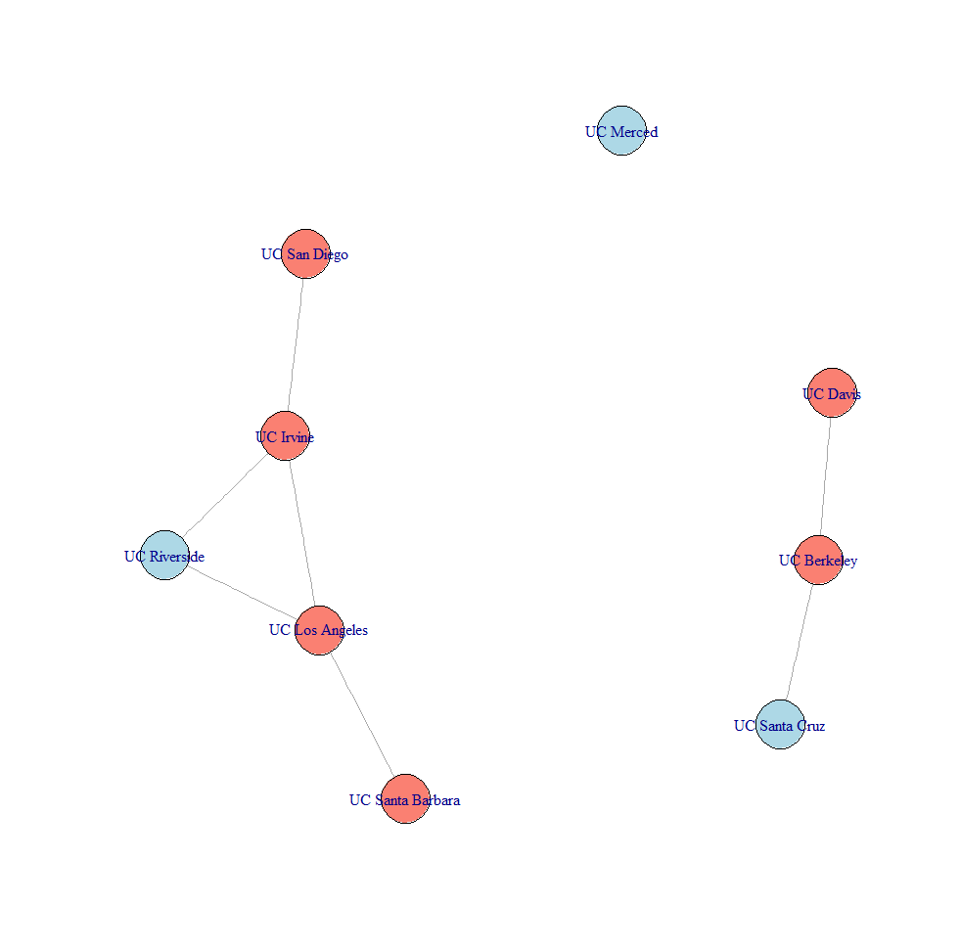

Appendix

Some parts of my codes include superassignment operator <<- for convenience

